WHY ORM & JPA EXIST ?
(What JDBC couldn’t solve and how Hibernate + Spring Data JPA fixed it)
Evolution: From JDBC to Hibernate to Spring Data JPA
CASE 1 — JDBC – The Starting Point (Direct Database Access) (Pain Zone)
Imagine you are building a Java application and you need to store and read data from a database.
The first thing you do is write SQL queries to:
- Create tables
- Insert records
- Fetch data
- Update and delete rows
To connect Java with the database, you use JDBC (Java Database Connectivity).
What is JDBC?
JDBC Java Database Connectivity
JDBC is the low-level Java API that allows a Java program to directly connect to a relational database, send SQL queries, and receive results.
It is the foundation layer of all Java–Database communication.
JDBC acts as a direct bridge between Java and the database.
What does JDBC do?
JDBC provides:
- Database connection
- SQL execution
- Result fetching
- Transaction control
Without JDBC, Java cannot talk to any database.
JDBC is the last bridge before the database.
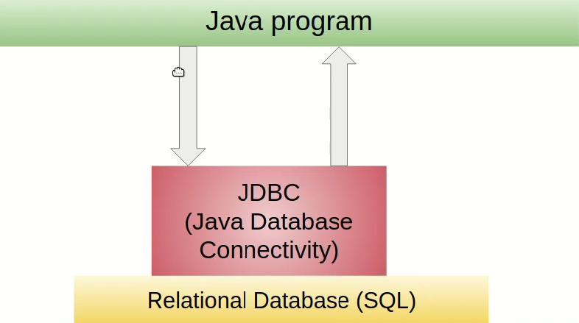

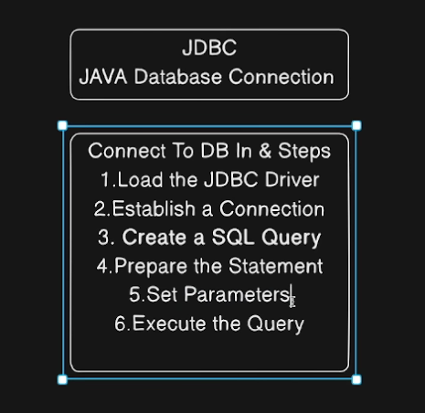
You manually:
- Open a connection
- Write SQL queries
- Execute them
- Read results from ResultSet
- Map them into Java objects
This works fine for small applications.
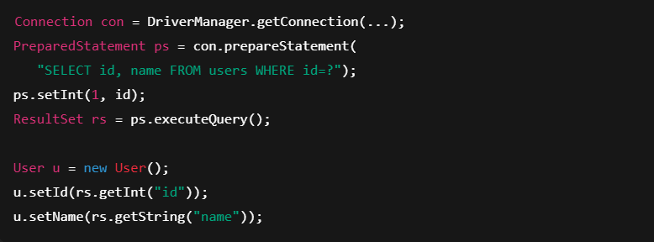
But as the project grows, your code becomes full of Problems :
- Repeated SQL
- Connection handling logic
- Error-prone mapping
- Database-specific code
- SQL everywhere
- Manual mapping
- Hard to refactor
- No abstraction
Your business logic slowly gets mixed with database logic, making the application hard to maintain and hard to scale.

Problem | Why it hurts
SQL everywhere | Business logic mixed with DB logic
Manual mapping | ResultSet → Object done by hand
Boilerplate | Too much repetitive code
Hard to maintain | Table change breaks Java code
No abstraction | DB structure controls your code
JDBC works — but does not scale for enterprise systems.

Case 2: Hibernate – Object-Oriented Abstraction
After some time, you get frustrated:
- Writing SQL everywhere
- Copy-pasting mapping code
- Fixing bugs when table structure changes
You want a way to work with Java objects instead of SQL queries.
This is where Hibernate (ORM framework) comes in.

What is ORM?
ORM Object Relational Mapping
ORM is a technique that maps Java objects to relational database tables and database rows to Java objects automatically.
It acts as a translator between the Object-Oriented world and the Relational Database world.
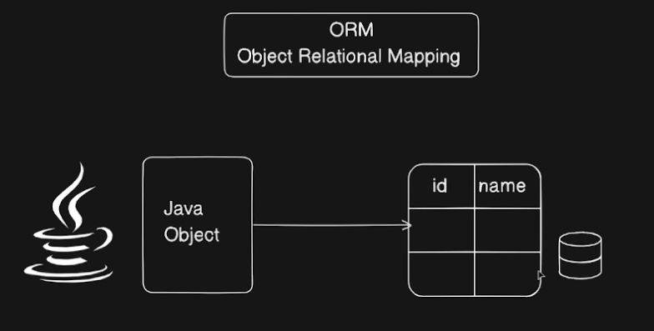

The real problem ORM solves
Java works with:
- Objects
- Classes
- Inheritance

Databases work with:
- Tables
- Rows
- Columns
- Foreign Keys
These two worlds do not naturally match.
Without ORM (JDBC style)
- You manually convert rows → objects
- You write SQL everywhere
- Your business logic becomes DB-dependent
ORM removes this gap.

Every table change breaks your code.

ORM:
- Reads annotations
- Builds mapping metadata
- Generates SQL
- Converts rows → objects
- Tracks object changes
- Syncs DB automatically

With ORM (Hibernate/JPA)
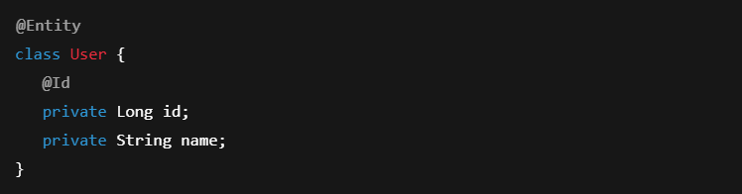

How ORM works internally
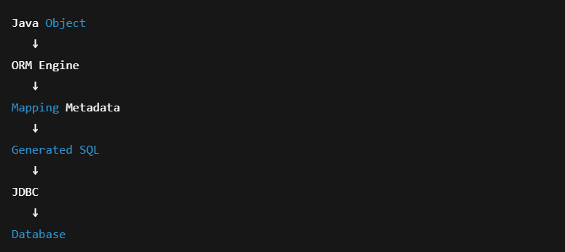And reverse for fetching.

JDBC exposes the database directly to your code.
This creates:
- Tight coupling
- Boilerplate
- Hard maintenance
- SQL everywhere
- Mapping chaos
So the industry created ORM.

ORM = Bridge between OOP world and Relational DB world
Problem with JDBC | ORM solution
SQL everywhere | SQL auto-generated
Manual mapping | Auto object mapping
Hard maintenance | Centralized mapping
No caching | First/Second level cache
No lifecycle | Entity state management

ORM lets you think in objects while the database thinks in tables — and handles the translation for you.

What is Hibernate?
Hibernate is an ORM framework that maps Java objects to database tables and automatically generates SQL queries.
You work with objects, not SQL.
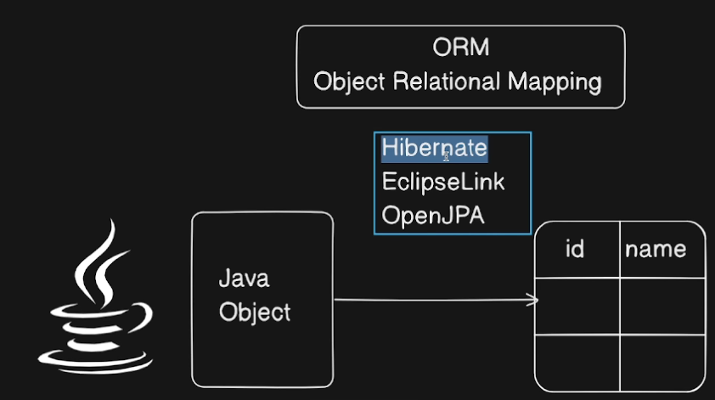

What Hibernate solves
With JDBC | With Hibernate
Write SQL | Write Java objects
Manual mapping | Auto mapping
Tight DB coupling | Loose coupling
No caching | First level cache
No lifecycle | Entity lifecycle

Hibernate:
- Reads @Entity annotations
- Converts objects ↔ rows
- Tracks changes (dirty checking)
- Auto-generates SQL
- Manages transactions

Hibernate flow
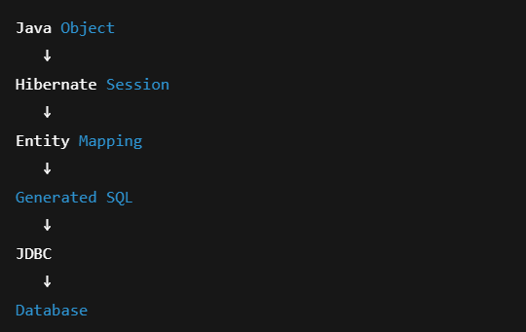
Hibernate still uses JDBC internally, but you never touch it
Hibernate:
- Reads annotations
- Generates SQL
- Maps row → object
- Manages transactions

With Hibernate:
- You create Java classes and mark them as @Entity
- You describe table mapping using annotations
- You work with objects, not rows

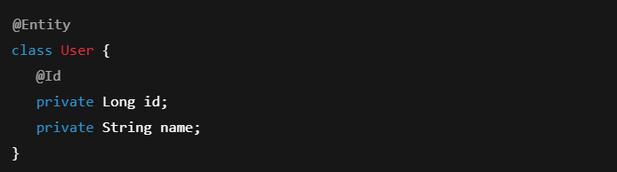
Now your flow becomes:
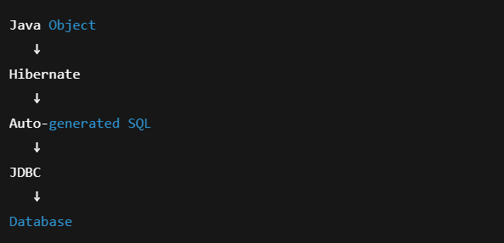
Hibernate:
- Translates Java objects into SQL
- Converts result rows back into objects
- Tracks changes automatically
- Reduces boilerplate
- Keeps your code clean and object-oriented
You still use JDBC internally — but you never touch it directly.

Case 3: JPA & Spring Data JPA – Enterprise Level Abstraction
Even with Hibernate, you still write:
- DAO classes
- EntityManager code
- Query logic
To make this even easier, JPA (Java Persistence API) standardizes ORM behavior, and Spring Data JPA builds on top of it.

What is JPA?
JPA Java Persistence API
JPA is NOT a framework. It is a specification.
It defines:
- How ORM should work
- Which annotations exist
- How persistence should behave

Examples of JPA implementations:
- Hibernate
- EclipseLink
- OpenJPA

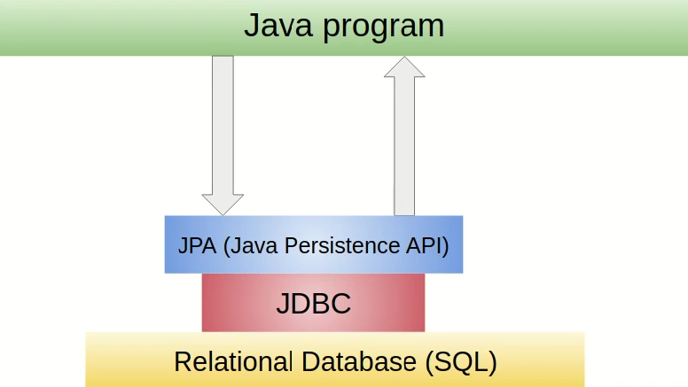

Hibernate implements JPA.
What is Spring Data JPA?
Spring Data JPA is a Spring abstraction built on top of JPA that removes repository boilerplate and gives auto-generated queries.
It:
- Auto-creates repository implementations
- Converts method names → SQL
- Manages transactions
- Integrates with Spring IoC container

With Spring Data JPA
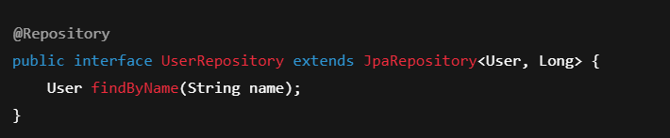No implementation.
No SQL.
Spring creates proxy beans at runtime.

Relationship Summary
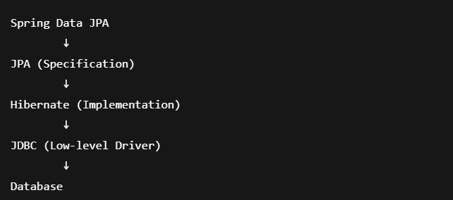

Layer | Role
JDBC | Physical DB communication
Hibernate | ORM engine
JPA | ORM rules/spec
Spring Data JPA | Developer-friendly abstraction

JDBC talks to DB, Hibernate maps objects, JPA defines rules, Spring Data JPA removes boilerplate.

Spring Data JPA gives:
- Ready-made repository interfaces
- Automatic query generation
- Transaction management
- Integration with Spring IoC container
Now you simply define:
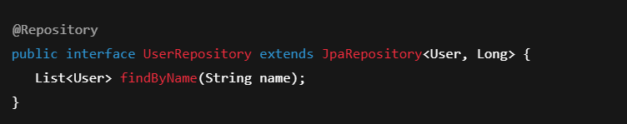No SQL.
No boilerplate.
Only domain logic.
And Spring:
- Creates the implementation
- Wires it as a Bean
- Manages transactions
- Calls Hibernate under the hood
So the final flow becomes:
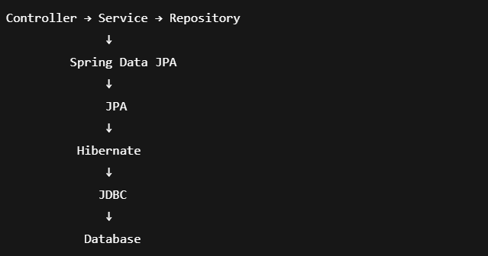
At this stage, you focus only on business logic, while Spring and Hibernate handle persistence.
JDBC connects Java to DB, Hibernate maps objects to tables, JPA defines the rules, and Spring Data JPA removes all persistence boilerplate.

HIBERNATE vs JPA vs SPRING DATA JPA
Feature | JDBC | Hibernate | JPA | Spring Data JPA
Level | Low | ORM | Spec | Abstraction
SQL | Manual | Auto | Auto | Auto
Mapping | Manual | Yes | Yes | Yes
Boilerplate | High | Medium | Medium | Lowest
Learning | Hard | Medium | Medium | Easy

Flow
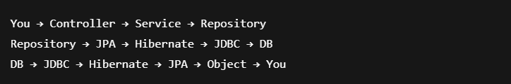

You start with JDBC.
You drown in SQL.
You crave abstraction.
Hibernate says “Think in objects.”
JPA says “Standardize this.”
Spring Data JPA says “Stop worrying about persistence. Build systems.”
This is not convenience, This is enterprise survival.

LAYERED ARCHITECTURE FLOW
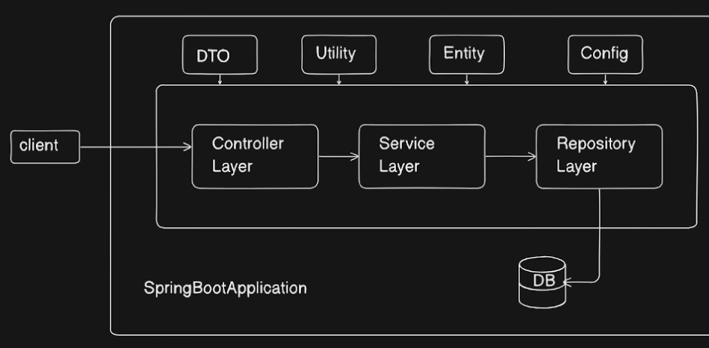
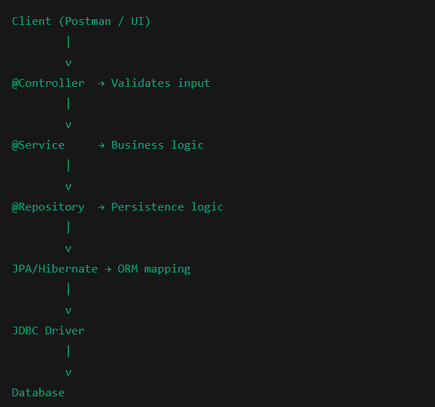
DEFINITIONS
Term | Meaning
JDBC | Java Database Connectivity – low-level DB API
ORM | Object Relational Mapping
Hibernate | ORM framework
JPA | Java Persistence API (spec)
Spring Data JPA | Spring abstraction over JPA
Entity | Java class mapped to DB table
Repository | Interface to perform DB ops
DTO | Data Transfer Object
@Entity | Marks persistent class
@Id | Primary key
@Repository | DAO layer
@Service | Business layer
@Controller | API layer
@Component | Generic Bean
IoC | Inversion of Control
Container | Spring runtime managing beans

